Explore Majors and Careers
Finding the Perfect Major for You!

Christy Huynh christy.huynh@oswego.edu
Annalise Winkler majorexploration@oswego.edu

145 Marano Campus Center
oswego.edu/careerservices

Major and Minor Elimination
Directions: Using pages 3 and 4 of majors and minors, take a moment and cross out the ones that you are certain you have no interest in. Next, circle the majors that you see as possibilities or if you would like to learn more about.
List the majors/minors you circled as possibilities here:
_________________________________________________________________________________________________________________________________________________________________________________________________________________________________________________________________________________________________________________________________________________________________________________________________________________________________________
Now categorize the majors/minors in 2-3 groups that make sense to you:
Group 1 Title: ________________________________________________

Group 2 Title: ________________________________________________

Group 3 Title: ________________________________________________

Majors
School of Business

Accounting – B.S.
Business Administration – B.S.
Finance – B.S.
Human Resource Management – B.S.
Marketing – B.S.
Operations Mgmt & Info Systems – B.S.
*Public Accounting – B.S./M.B.A.
Risk Management and Insurance - B.S.

School of Education
Adolescence Ed 7-12 – B.S.
Childhood Ed 1-6 – B.S.
TESOL – B.S.
Technology Ed All Grades – B.S.
Technology Management – B.S.
Vocational Teacher Prep (all majors) – B.S.
Wellness Management – B.S.

College of Liberal Arts & Science

American Studies – B.A.
Anthropology – B.A.
Applied Mathematics – B.S.
Applied Mathematical Economics – B.S.
Biochemistry – B.S.
Biology – B.A. or B.S.
Chemistry – B.A. or B.S.
Cinema and Screen Studies – B.A.
Cognitive Science – B.A. or B.S.
Computer Science – B.A. or B.S.
Creative Writing – B.A.
Economics – B.A.
Electrical and Computer Engineering - B.S.
English – B.A.
French – B.A.
Gender and Women's Studies – B.A.
Geochemistry – B.S.
Geology – B.A.
Geology Track I Geology - B.S.
Geology Track II Env. Earth Science - B.S.
German – B.A.
Global & International Studies – B.A.
History – B.A.
Human Development - B.A.
Information Science – B.A.
Language & International Trade – B.A.
Linguistics – B.A.
Mathematics – B.A.
Meteorology – B.S.
Philosophy – B.A.
Philosophy-Politics & Economics – B.A.
Philosophy-Psychology – B.A.
Physics – B.A. or B.S.
Political Science – B.A.
Psychology – B.A.
*Psych/Business Admin – B.A./M.B.A.
*Psych/Human Comp Intrctn – B.A./M.A.
Public Justice – B.A.
Sociology - B.A.
Software Engineering - B.S.
Spanish – B.A.
Zoology – B.A. or B.S.
School of Communication, Media, & the Arts

American Studies – B.A.
Art – B.A. (Studio, Art History, Graphic Design)
Art – B.F.A. (Graphic Design)
Art – B.F.A. (Studio Art)
Broadcasting & Mass Comm. – B.A.
*Broadcasting/Business Admin – BA/MBA
Comm. & Social Interaction – B.A.
Gender & Women's Studies – B.A.
Information Science – B.A.
Journalism – B.A.
Music – B.A.
Public Relations – B.A.
Theatre – B.A.
Minors
School of Business
*Accounting
*Arts Management
Business Administration
*International Business

School of Education
*Athletic Coaching
*Health Science
*Nutrition
*Technology

College of Liberal Arts & Sciences

*African/African-American Studies
Anthropology
*Applied Statistics
*Astronomy
*Biocultural Anthropology
Biology
Chemistry
Cognitive Science
*Computer Information Systems
Computer Science
Creative Writing
*Digital Humanities
Economics
English
*Expressive Arts Therapy
*Forensic Science
French
*French Culture Studies
Gender and Women's Studies
Geology
German
*German Culture Studies
*Gerontology
Global and International Studies
History
Human Development
*Italian Culture Studies
Linguistics
*Logic
Mathematics
*Medieval and Renaissance Studies
*Native American Studies
*Peace and Conflict Studies
Philosophy
Physics
Political Science
Psychology
Public Justice
Sociology
Spanish
*Sports Studies
*Sustainability Studies
Zoology

School of Communication, Media & the Arts

Art
Art History
*Arts Management
*Audio Design and Production
Communication and Social Interaction
*Dance
Graphic Design
*Illustration
Journalism
*Live Event Design
*Museum Studies
Music
*Photography
Theatre

*Minor only
Dissecting a Major Worksheet

Directions: Choose one of the majors from page 2 and fill in the below information using the SUNY Oswego College Catalog. Available online: http://catalog.oswego.edu

Major: ___________________________

Summary of the Major Description:

Rate each course utilizing the following scale:
1 2 3 4 5 6 7
Extremely Neither Extremely
Draining Draining/Energizing Energizing

Course | Ranking | Comments

Weighing Your Options

If you are trying to choose between just a few majors, you can use these charts to help you outline the pros and cons of each one. Choose possible careers using the “What Can I Do with a Major In…?” chart to help in making your decision: oswego.edu/career-services/what-can-i-do-major

Major: ______________________________________  Possible Career(s): ____________________________  Pros Cons | Major: _____________________________________________  Possible Career(s): __________________________________  Pros Cons
Major: _____________________________________  Possible Career(s): _____________________________  Pros Cons | Major: ___________________________________________  Possible Career(s): __________________________________  Pros Cons

Strategies for Exploring and Confirming Majors

- Learn more about my Interests, Values, Abilities, and Strengths through Inventories and Assessments
  - Focus2 – A career and education planning tool that includes assessments and a customizable portfolio.
  - StrengthsQuest – StrengthsFinder is an online assessment that identifies your “top 5” Themes of Talent.
  - MBTI (Myers-Briggs Type Indicator) –A personality assessment that identifies your preferences as it relates to who you are and why you want to work; including the best work environments and career tasks.
  - Strong Interest Inventory – An interest inventory that matches your interests with career fields.

- Investigate all majors and minors that SUNY Oswego offers
Review the Undergraduate Catalog and departmental websites for majors/minors of interest. Get an understanding for course work and degree requirements for different majors. Complete these activities to narrow your search:
  - “Major-elimination” activity find out what majors interest you the most.
  - “Dissect a Major” activity helps to identify if a potential major is truly a good fit.

- Take a course in a major or minor of interest
Many majors offer introductory courses. Many of these courses fulfill general education requirements and can be taken to explore majors.

- Job Shadow/Informational Interview
Spend a day with a professional in the field or interview a professor about their discipline. This is a great way to learn firsthand about a career field or major. Sophomores may utilize the Alumni Sharing Knowledge (A.S.K.) program to connect with alumni in their career field of interest. To learn more visit http://www.oswego.edu/alumni/ask
Other networking opportunities include:
  - Talk to an upper-class student about their major or connect with the expert faculty/staff in that department.
  - Utilize the Informational Interviewing videos https://www.oswego.edu/career-services/networking
  - Check out “Candid Career” Informational Career Videos online! oswego.edu/career-services/careers

- Service Learning and Community Service
Volunteer in the community either independently or through a Service Learning, GST302. Choose a site related to a field or major of interest to acquire skills and knowledge of real world settings. https://www.oswego.edu/community-service/home

- Leadership in Your Field (GST303), Internship (GST498), or Professional Skills Preparatory (GST101)
Gain insight about a major or career field that interests you. Visit center for Experiential Learning in the Compass, 145 Campus Center for more information about experiential learning. https://www.oswego.edu/center-for-experiential-learning/

Career Exploration

- Learn more about careers related to majors you are exploring- all available through Career Services

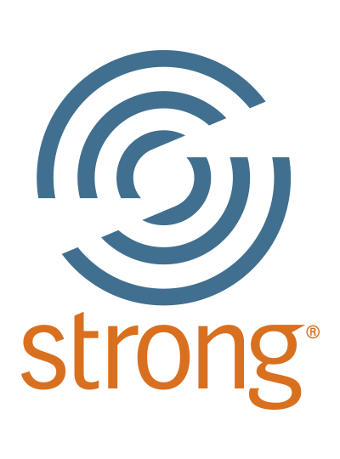 | Strong Interest Inventory  an interest inventory that matches your interests with career fields
What Can I Do with A Major In…
provides information about careers & resources for every major

Focus 2- search career fields related to your interests, skills and values.
https://www.focus2career.com/Portal/Login.cfm?SID=799

O*Net – Search for information about occupations
http://onetonline.org

Candid Career – browse thousands of career videos
https://www.oswego.edu/career-services/careers

Self Assessments

Career Services offers a variety of assessments that provide you with information about your strengths, values, interests and skills. If you are interested in completing an assessment, email majorexploration@oswego.edu

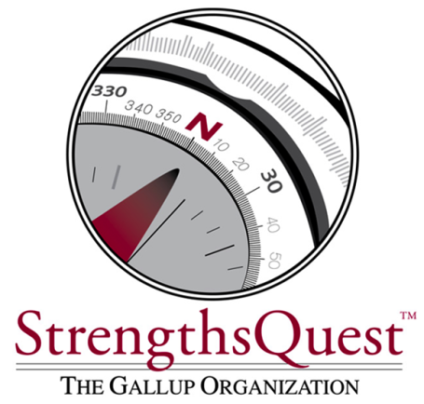
StrengthsQuest
StrengthsFinder is an online assessment that identifies your “top 5” Themes of Talent. StrengthsQuest allows you to explore and strengthen your talents, use your strengths to improve your academics, discover a major and career path that builds off of your strengths and learn to use your strengths to excel.

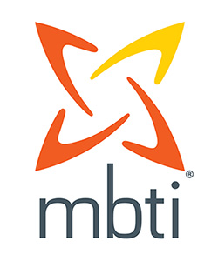
MBTI (Myers-Briggs Type Indicator)®
MBTI identifies your preferences and provides information about your unique type (there are 16 distinct types). Understanding your personality type/preferences is the foundation of major exploration and this is a great tool for helping you to understand who you are and what majors would be a good fit for you. The MBTI gives you information about how you orient in the world, take in information, make decisions and structure your life.

Strong Interest Inventory®
The Strong Interest Inventory is a tool that matches your interests with majors and career fields. It helps you identify your interests, preferences, and personal styles and provides information you need to select a major and career you can be passionate about.

Focus2
Focus2 is a web-based program that includes five online self-assessments (work, interest, personality, skills, values, and leisure interests), a career portfolio and information about careers.

