The Break-Up Cure: 7 Ways to Heal and Find Happiness Again
Published on January 20, 2013 by Preston Ni, M.S.B.A. in Communication Studies
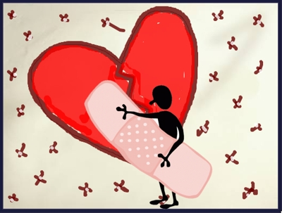
“To be beautiful means to be yourself. You don’t need to be accepted by others. You need to accept yourself.” –Thich Nhat Hanh

Losing a significant relationship in life is never easy, especially after you and your former partner walked a journey together. It can feel like amputation, and you may feel sad, alone, angry, rejected, betrayed, or as if you are missing a huge piece of yourself. The good news is that these feelings don’t last forever, and brighter days lay ahead. Here are some tips to finding joy again:

1) Let Yourself Grieve- When we feel pain from a loss, allowing ourselves time to grieve is one of the most important steps in the healing process. Find health outlets where you can express emotions, for example: crying, talking to supportive friends, journaling, or seeking counseling can be helpful during difficult times.

2) Take Care of Yourself- There may be an urge to feel sorry for or to blame oneself after separation, and in doing so neglect one’s own wellbeing. The more difficult the break-up, the more important it is to take care of yourself. Eat well and exercise. Do something to pamper yourself everyday- it could be a hot bath, fragrant tea, fresh flowers, or a massage at a spa. Be your own best friend- you absolutely deserve it!

3) Surround Yourself with Healthy Support- As you heal, the support and encouragement of loved ones are so important. Embrace the affection of friends, family, or a beloved pet. When reflecting on things with others, try to avoid constantly revisiting the past or rehashing old wounds. Aim to focus on the positives!

4) Engage in Physical Activities- How we use our bodies greatly influences how we feel. The easiest way to feel lousy about yourself is to sit like a couch potato and wallow in misery. Conversely, healthy and enjoyable activities such as singing and dancing can energize the body and lift spirits. Go have fun and get active-it’s time to start feeling good!

5) Allow Yourself Peaceful Solitude- Allow yourself to be comfortable in your own company. Engage in enjoyable, solitary activities that let you to feel peace and vitality on your own. Examples are: walking, cooking, art, gardening, traveling. Get to know yourself again!

6) Participate in Meaningful Work- The next tip is to try to reach out and help others in greater need than you. Volunteer at a soup kitchen, visit an elderly home, or engage in other types of meaningful work. Realize how fortunate you are. Let the service fill your heart with love, gratitude, and a new perspective.

7) Get Back on Your Feet Again- The final tip is to simply get on with your life, knowing that your future is full of new and exciting possibilities! There is a right partner for everyone-it may take time to find that person, and require a good dose of personal growth to attract him or her, but you will find that person when the time is right. When that day comes, as you rest in the arms of that special someone, you’ll realize that everything happens for a reason, the search is over, and your courageous self-discovery has led you to find that love.

