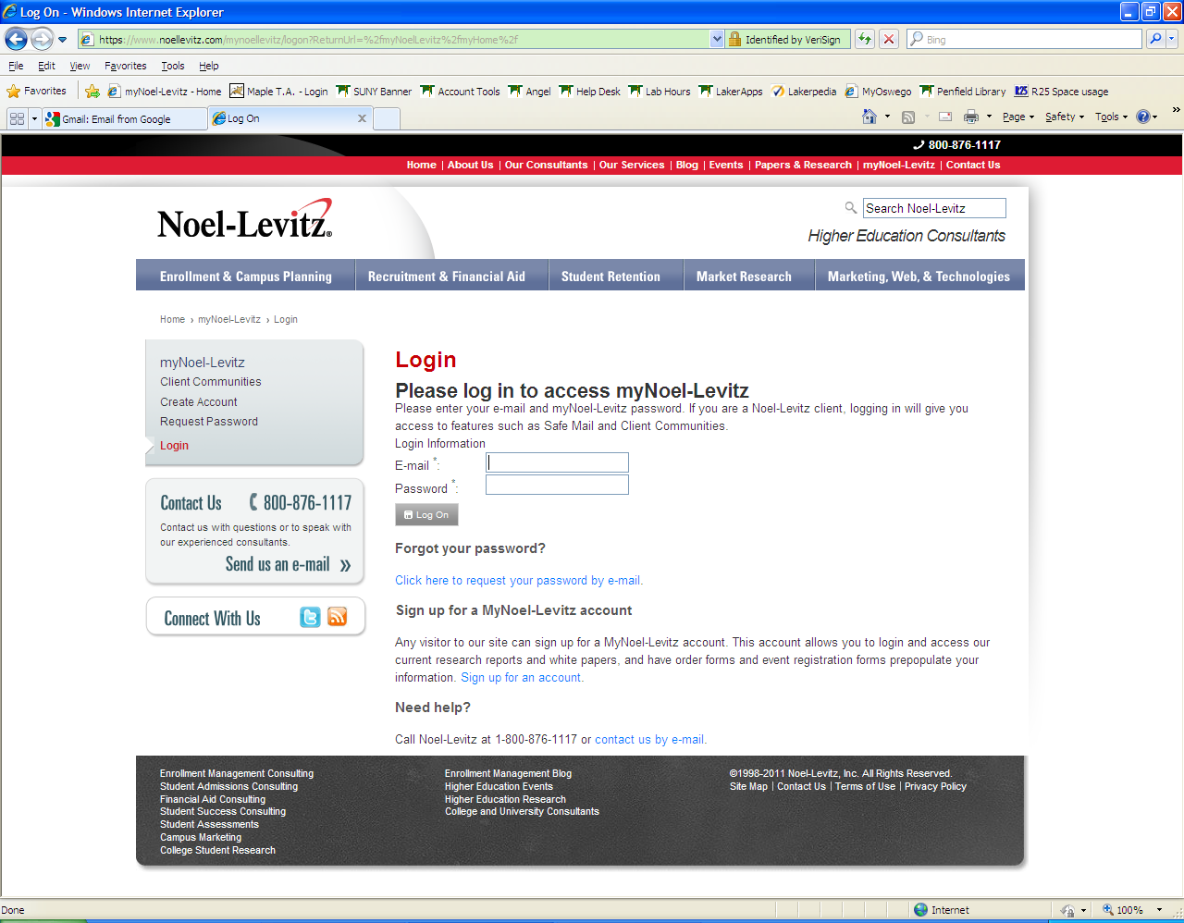
Above is the home page for the Noel-Levitz College Student Inventory (CSI/RMS) report. The web-site is
https://www.noellevitz.com/MyNoelLevitz/LogOn
If you do not remember your log in information please contact the First Year Programs Department at 315-312-3349 or email firstyear@oswego.edu.
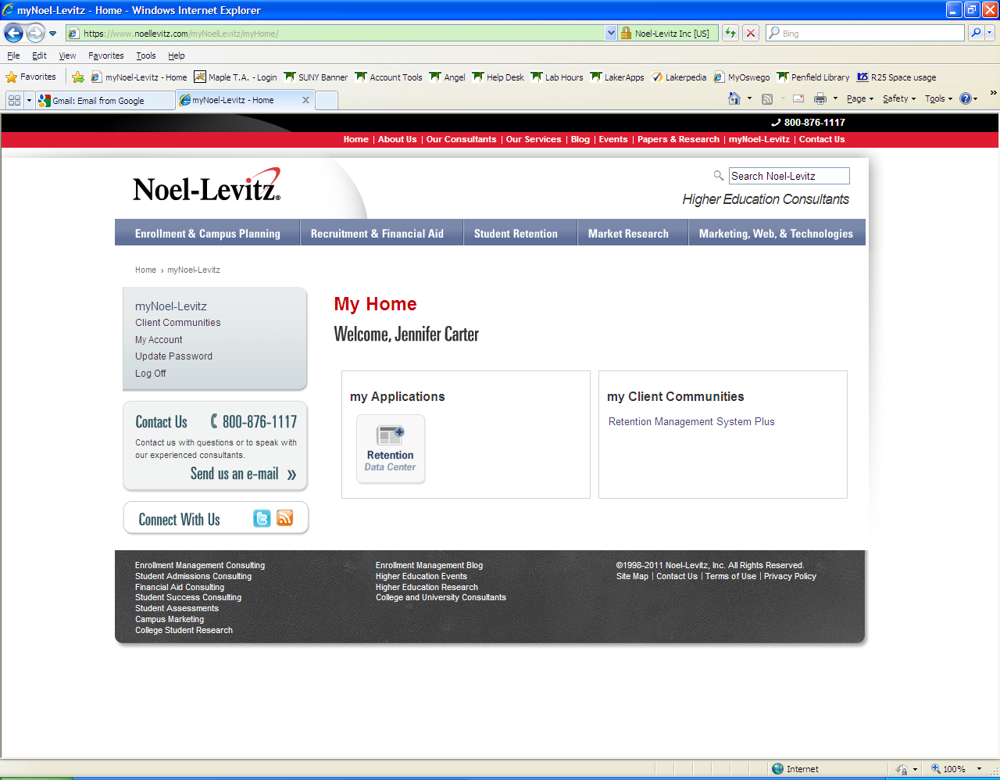
Once you have logged in you should come to this page. If this page is not appearing on your screen go to the top red bar and click on myNoel-Levitz
You will then click on the Retention Data Center box under my Applications
The FERPA information will appear, click OK.

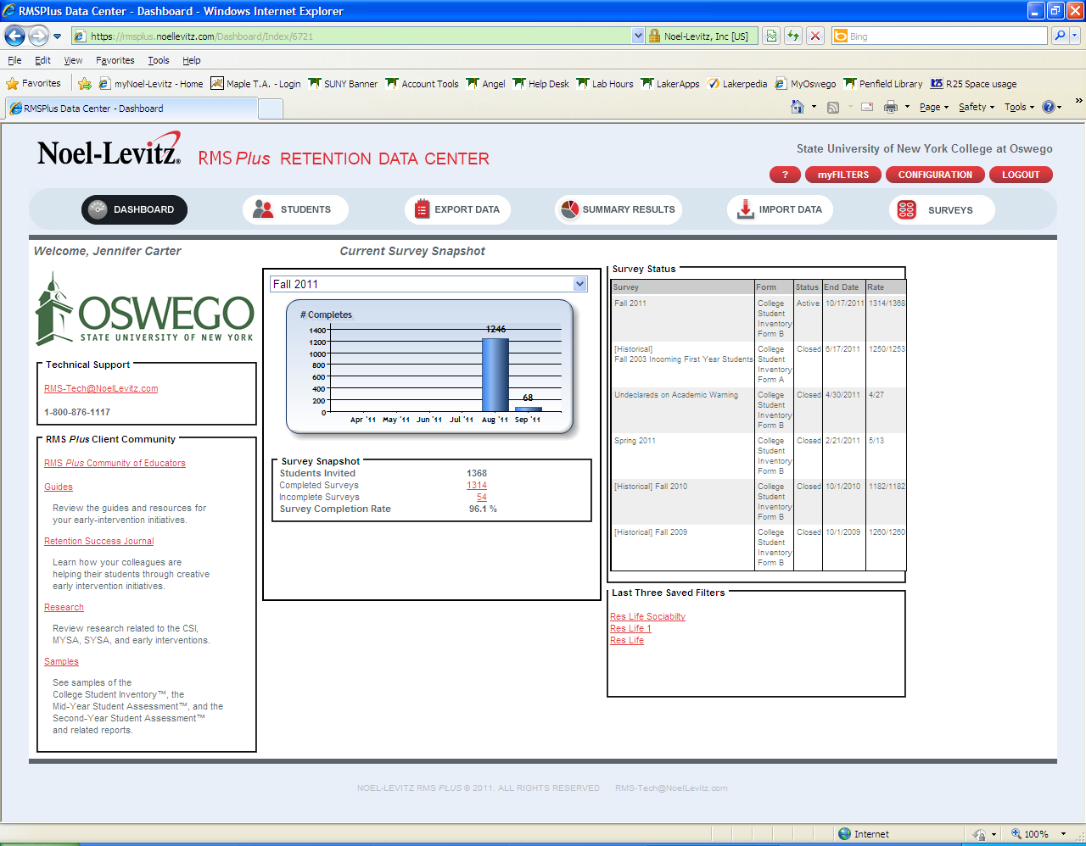
This screen should appear. If no survey information appears, select Fall 2011 from the drop down list in the center box under Current Survey Snapshot.
Click on the Red number next to Completed Surveys to see your student’s reports. You can also click on the Red number next to Incomplete Surveys to see which of your students still need to complete the survey.
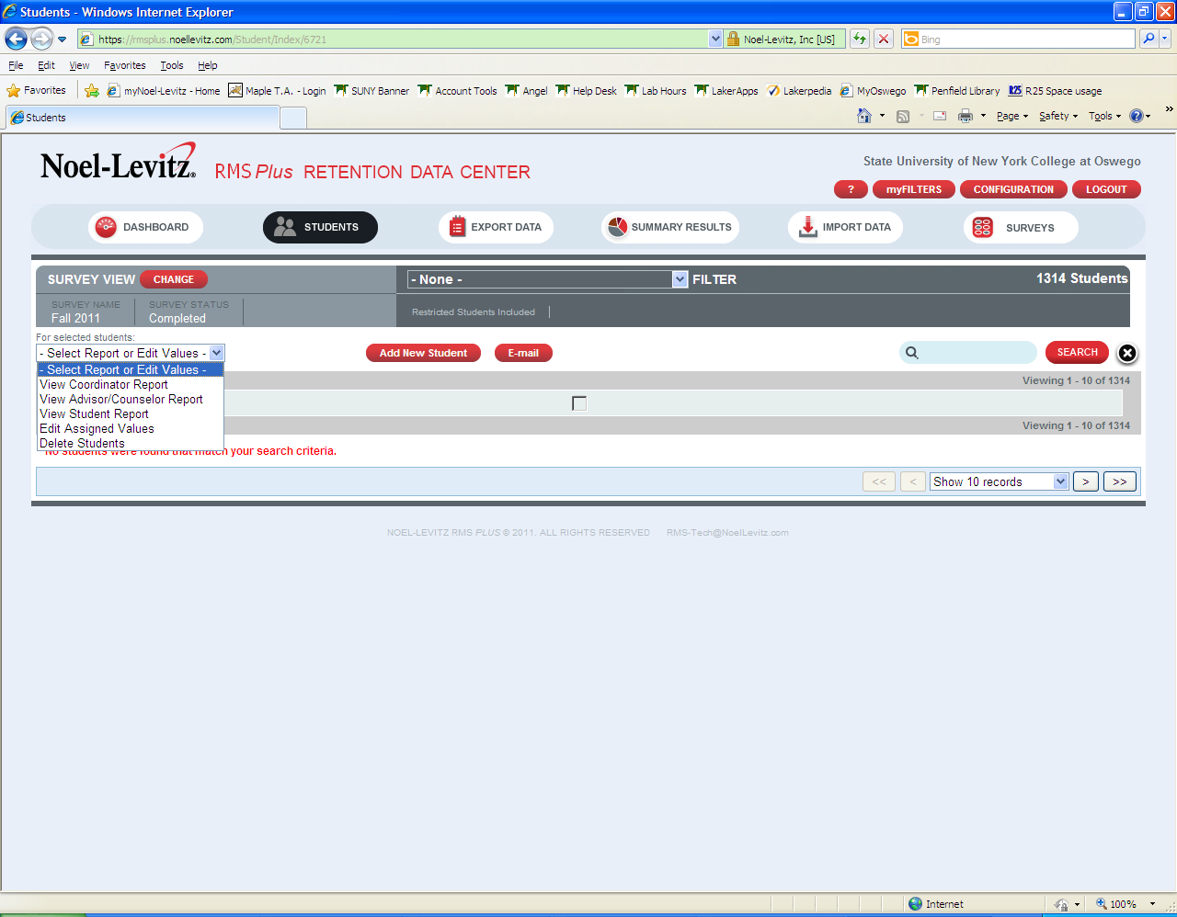
A list of all of your students should appear. If you get “No Students were found…” message contact First Year Programs at 315-312-3349 or email firstyear@oswego.edu.
Check the box next to the student that you want to review.
Under the drop down on the left side, Select Report or Edit Values (shown above), you can choose to select the Advisor’s Report or the Student’s Report. Both reports reflect the same results, with the exception that the Student’s report has additional information stating what each result means.
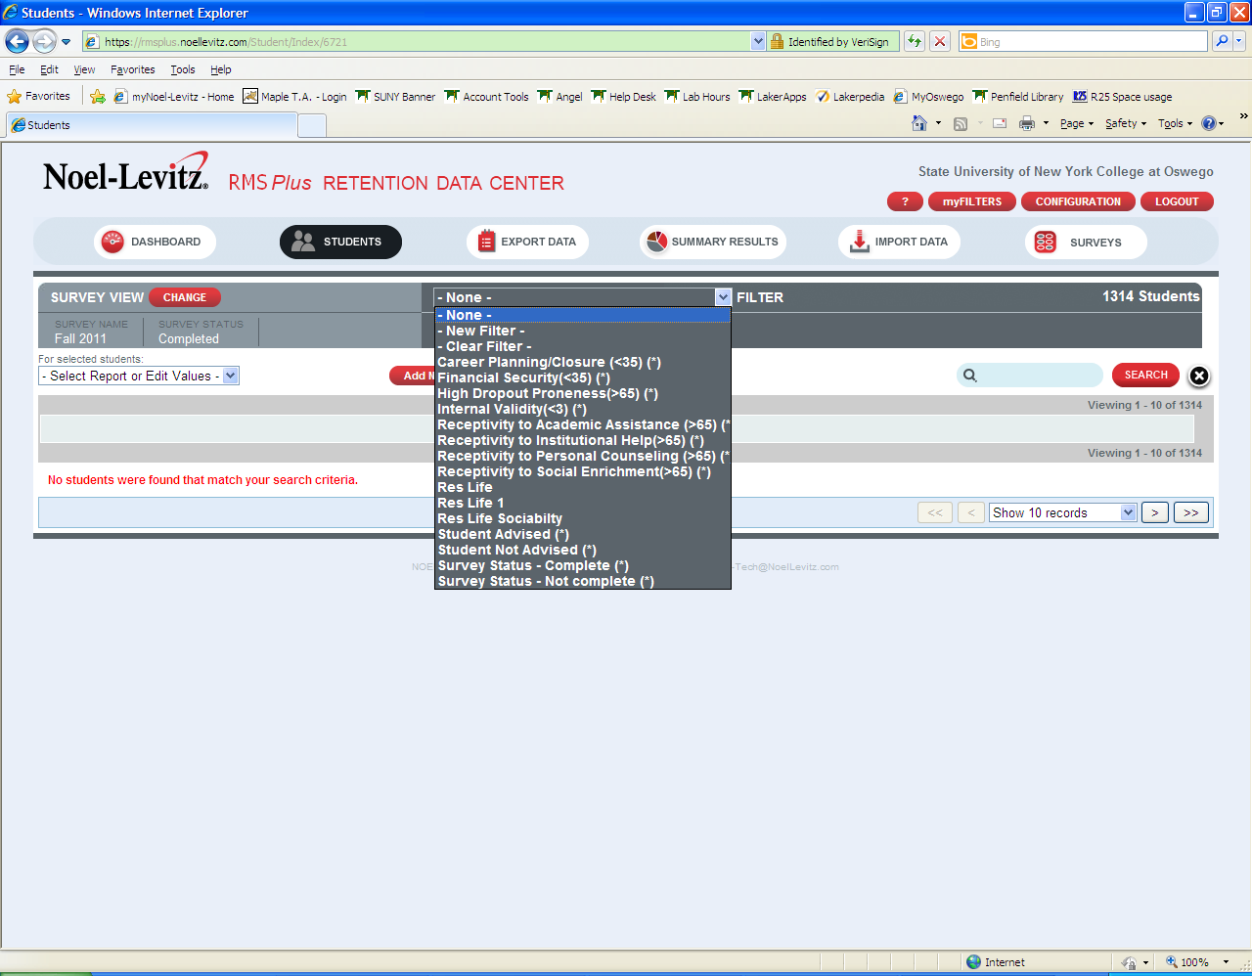
Under the Filter dropdown (shown above), you can find the results of different reports that will help you to determine at risk students. Once you pull up a specific report it will pull only the students that fall into those categories.

If you have any questions or need additional assistance please contact First Year Programs at 315-312-3349 or email at firstyear@oswego.edu.

