SUNY Oswego
Login myOswego Instructions
for
High School Program Instructors

To activate your account, go to the link below, then click the Agree button at the bottom.
Please review this entire document, before proceeding. You may prefer to print this document to have as a reference as you complete the process.
NOTE: If you already have access to myOswego and a Laker NetID, you do not need to complete the account activation steps. You may simply begin grading using the procedures beginning on page 4.
https://www.oswego.edu/account-tools/email/
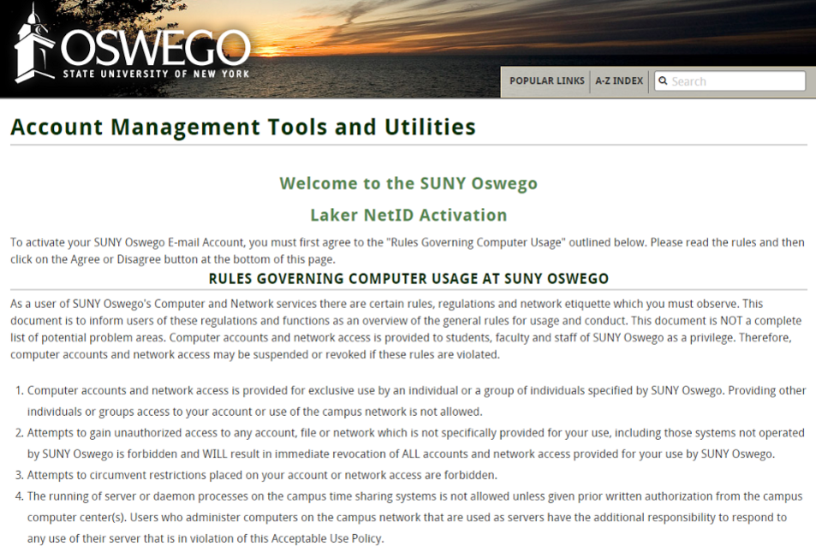
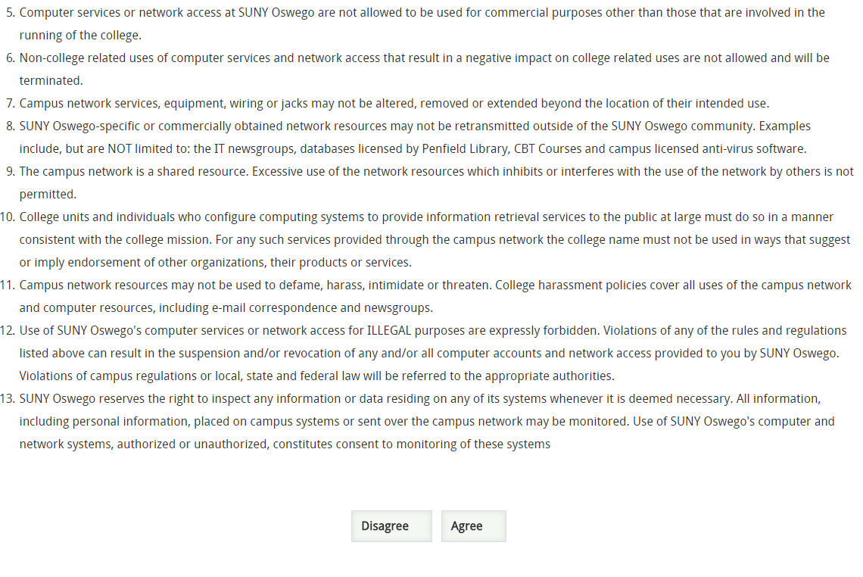

Enter your Date of Birth and the Campus ID number you were provided, then click Submit. This will prompt you to set a password.
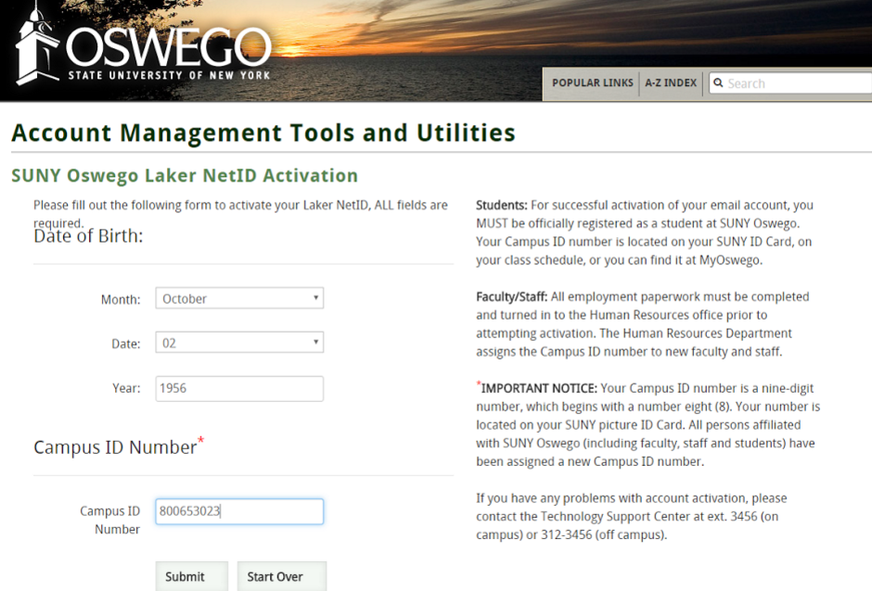

Please disregard this Student, Faculty/Staff and Important Information text. It applies to SUNY Oswego students and staff only.
If you have questions regarding this screen, please contact the Registrar’s Office at
(315)312-2136.

The following screen will appear, stating your account is now active.
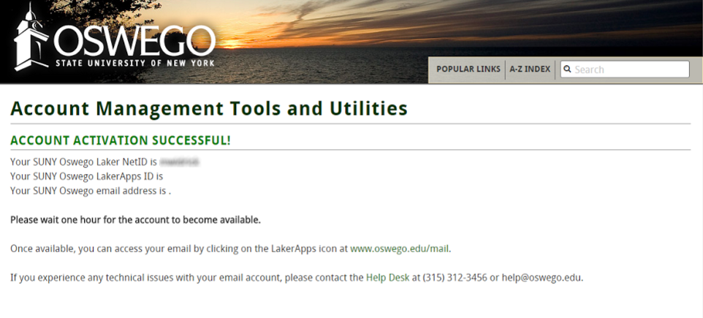
Please note that High School Program instructors are not assigned a SUNY Oswego email address.
Please be certain to make note of your Laker NetID! You will need this to login to myOswego.

To login, go to myOswego:
https://www.oswego.edu/myoswego/

Click the “Single Sign On” button
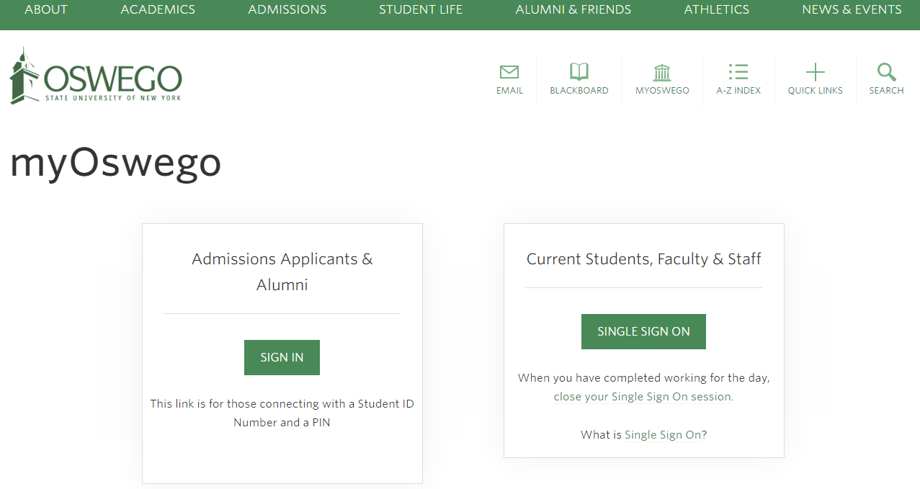
Enter your login information (LakerNet ID and Password), then click LOGIN

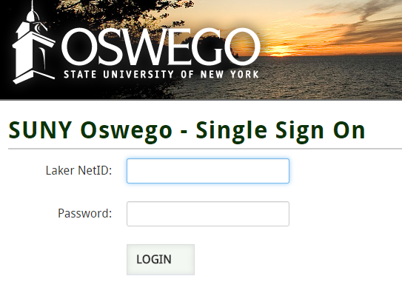

Select/click Faculty Services
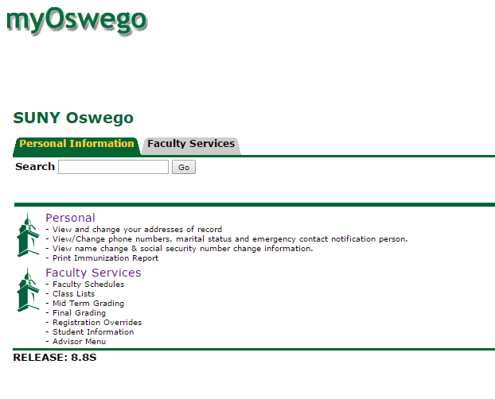

You will be able to view or download your class list soon.
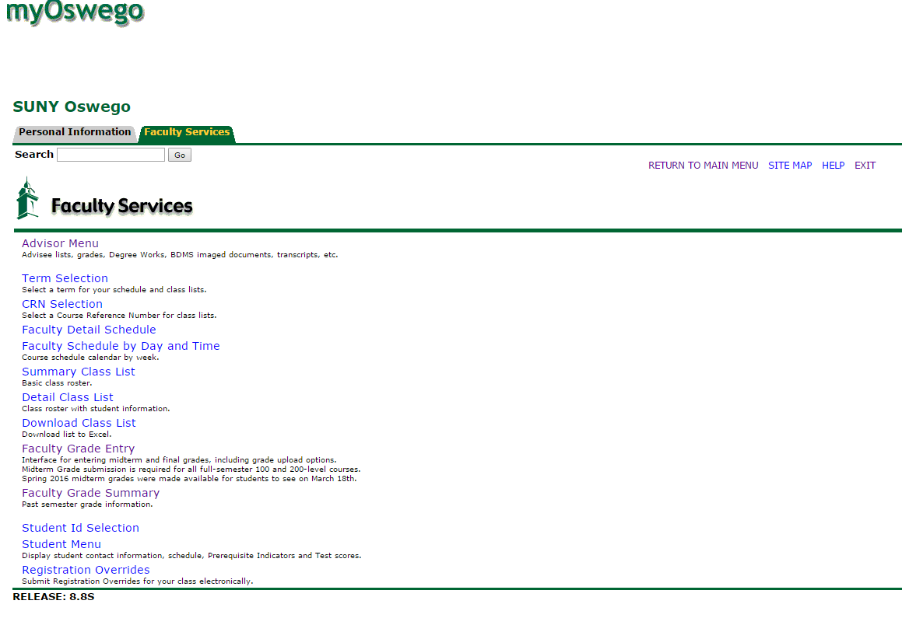

Your courses will be listed. Simply select the specific course section to view.

