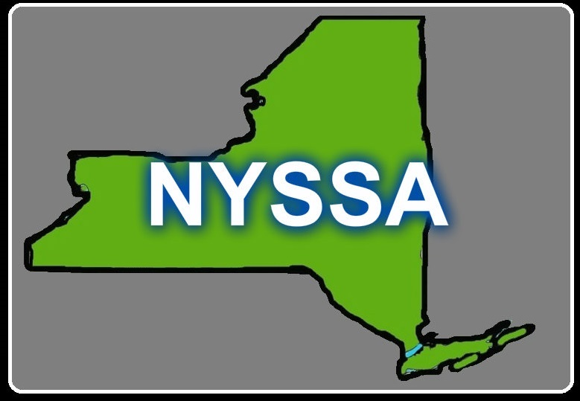
2015 NYSSA Conference Registration Form

“Boots on the Ground: Doing Public Sociology”

63rd Annual Meeting, October 2-3, 2015
www.oswego.edu/nyssa

Registration Information: Please type or print legibly.

Last Name _____________________________ First Name ____________________________________
Work Affiliation (s) for conference badge __________________________________________________
Preferred Mailing Address ______________________________________________________________
____________________________________________________________________________________
Daytime telephone: ( ) ________________________ E-Mail _________________________________
Number of past NYSSA conferences you have attended: ( ) None ( ) 1-5 ( ) 6-10 ( ) More than 10

Registration Fees (U.S. $) Check appropriate categories. (All presentators must be NYSSA members.)
Prepay On-site (and after 9/15)

( ) Professional Member $75.00 $80.00
(Includes conference registration, one year NYSSA membership, conference materials, and Saturday continental breakfast.)

( ) Student Member $25.00 $29.00)
(Includes conference registration, one year NYSSA membership, conference materials, and Saturday continental breakfast.)

( ) Nonprofessional guest $35.00 $40.00
(Includes all above mentioned benefits)

( ) Friday Keynote Dinner with Trevor R. Pinch $25.00 $30.00
(Please indicate preference: ____ Vegetarian ____ Non-vegetarian)

( ) Saturday Award Luncheon with TBA $15.00 $20.00
(Please indicate preference: _____ Vegetarian ____ Non-vegetarian)
Total $_______ $_______

Please send check or money order only. On-site registration will accept cash, check, or money order.

Return form with payment to:
NYSSA 2015 – SUNY Oswego, c/o Dr. Tim Delaney, NYSSA President
311A Mahar Hall, SUNY Oswego, Oswego, NY 13126
Email: Tim.Delaney@oswego.edu

Hotel information and directions to SUNY Oswego are provided on our website.

