
www.oswego.edu

SCHOOL OF EDUCATION
Department of Technology
OSWEGO, NEW YORK 13126
www.oswego.edu/tech

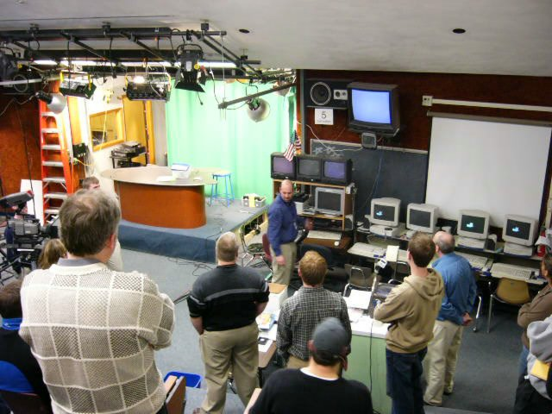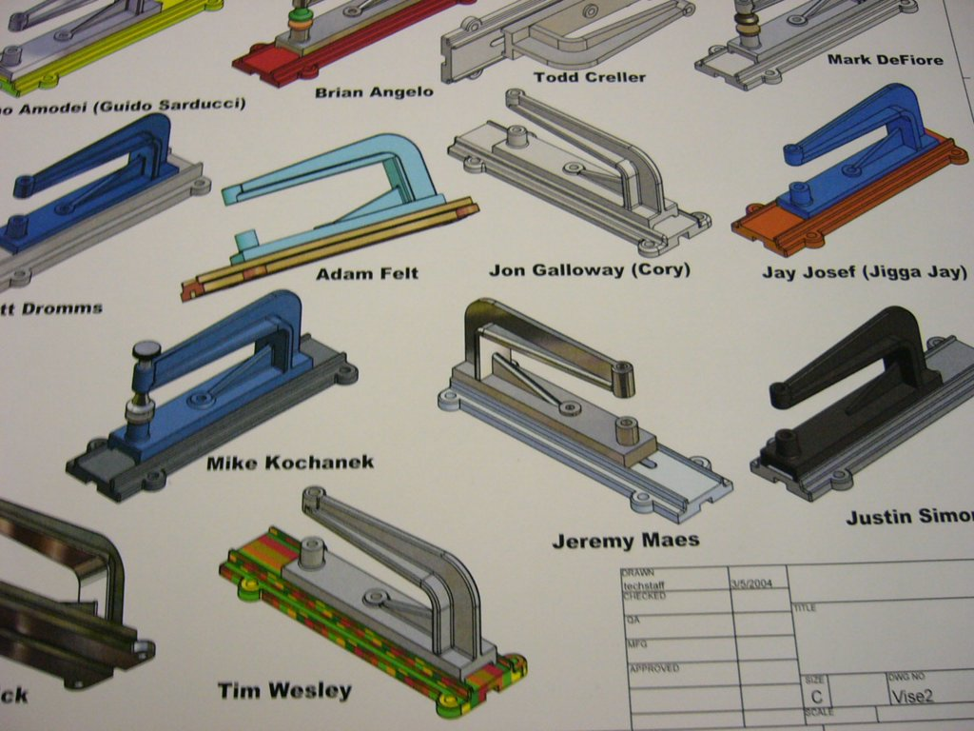

MASTER’S DEGREE HANDBOOK

MASTER’S OF SCIENCE IN EDUCATION
MAJOR IN TECHNOLOGY EDUCATION

Department Office
209 Park Hall
315-312-3011

College Graduate Office
602 Culkin Hall
315-312-3152

STATE UNIVERSITY OF NEW YORK
COLLEGE AT OSWEGO
SCHOOL OF EDUCATION
Department of Technology
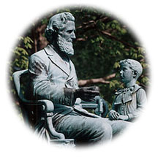
OSWEGO, NEW YORK

MASTER’S DEGREE HANDBOOK

M.S. IN TECHNOLOGY EDUCATION

Introduction

The Department of Technology at SUNY Oswego offers the Master of Science in Education program for Technology Education teachers seeking to obtain professional (permanent) certification. This program has a rich heritage, beginning in 1948, and has served the field well over these decades. It is currently ranked the largest nationally in graduates per year.

This handbook is a supplement to the college graduate catalog. Students are expected to acquaint themselves with the program requirements for graduation and assist their adviser in maintaining up-to-date office records.
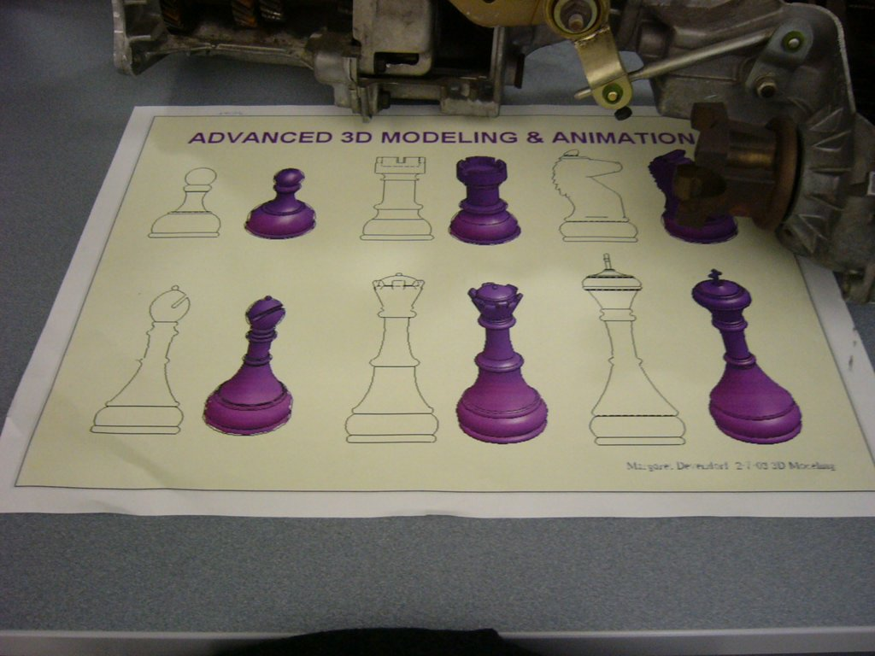

Graduate Student Advisement

Graduate students are assigned a faculty adviser when they are admitted to the program. The assignment may be changed upon the request of the student and the agreement of the department chairperson.

Students are required to meet with their adviser to develop an approved program of appropriate studies. A long-range planning form should be completed. The adviser, or another member of the graduate faculty must approve all course registration forms, in the adviser's absence.

Students who interrupt their progress toward the degree or who otherwise change their plans should notify their adviser. Changes of address should be sent to the department office and the graduate office.

Admission Requirements

Admission to the Master of Science Degree program in the Department of Technology is available to persons holding an undergraduate degree or initial (provisional) certification in Technology Education. Also, those holding a baccalaureate degree in any field that is adequately related to the M.S. degree, along with an initial teaching certificate, may be admitted as determined by the department chairperson.

Admission Procedures

A student must apply for admission to the State University of New York, College at Oswego, Graduate Office, 602 Culkin Hall, Oswego, New York, 13126 (315-312-3152).

Application materials include:
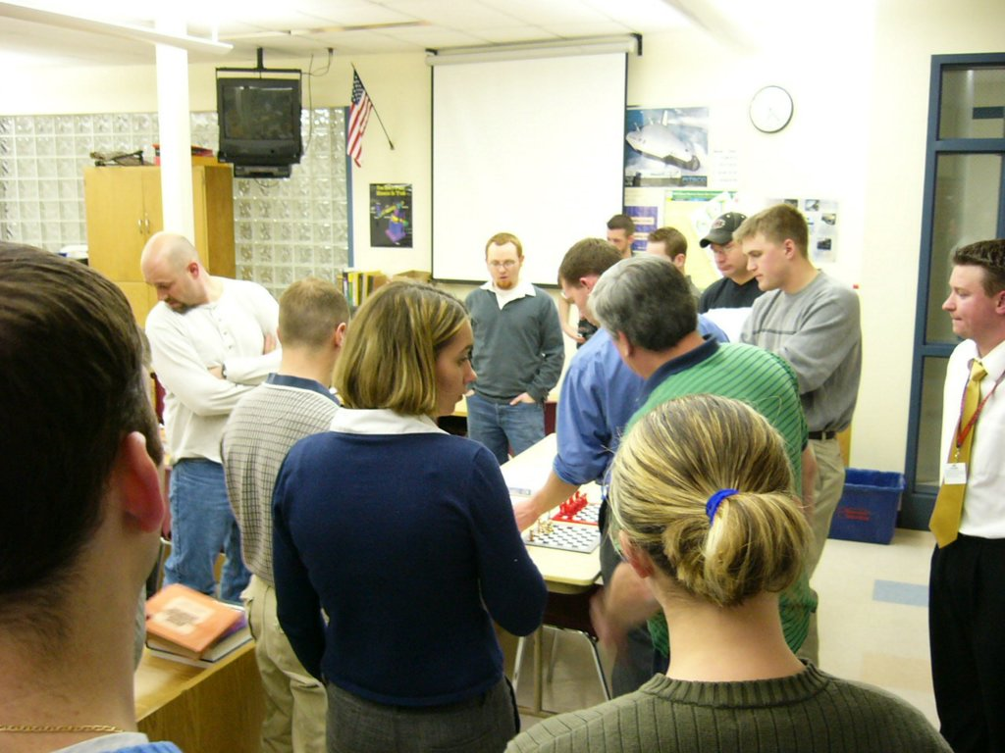
- Baccalaureate degree from an accredited institution
- Degree application form
3. Two copies of official transcripts of undergraduate and graduate work
- Three letters of recommendation
- Initial teaching certification (may be waived by chairperson)

The following criteria are used to establish admission:

- Appropriate undergraduate preparation (as determined by chairperson)
- Evidence of scholarly ability indicated by (a) an undergraduate GPA of at least 2.50 where 4.00 is the maximum, (b) a graduate GPA, if any, of 3.00, and (c) letters of reference submitted
- Evidence of commitment to teaching Technology Education or a related field (may be waived by chairperson)
- Motivation to complete the M.S. degree program
- Evidence of satisfactory student teaching and/or teaching experience

Admission Status

1. Regular Admission

Persons who meet or exceed all admission guidelines will be recommended for admission without reservation.

2. Conditional Admission

Applicants who do not qualify for regular admission will be recommended for conditional admission. They will be permitted to complete two core courses and one other 3 sh graduate courses. The department may specify additional coursework, with or without applicable credit to the degree, for the purpose of rectifying identified deficiencies. Upon completion of those courses the application for admission will be re-evaluated on the basis of the final marks and the recommendations of the instructors of those courses when necessary. The student must have at least a 3.00 cumulative index in the graduate work taken under the conditional admission. The decision about admission will be final. A maximum of 9 sh completed prior to regular admission can be applied to the M.S. degree program. At least 21 hours must be started and completed after regular admission to the degree program.

Transition to New Graduate Program - Beginning Fall 2005

Those already enrolled in the program will make the following substitutions using the new course numbers.

If you needed… | Now take…
TED 502 – TE in American Schools | TED 531 - History and Philosophy
TED 506 - Evaluation | TED 534 - Assessment
TED 516 – Analysis of Teaching | TED 532 – Adv Instructional Methodologies
TED 521 – Curriculum Development | TED 533 – Curriculum Development
TED 522 – Laboratory Planning | TED 535 – Laboratory Environments
TED 525 – Applied Research | TED 536 – Introduction to Research

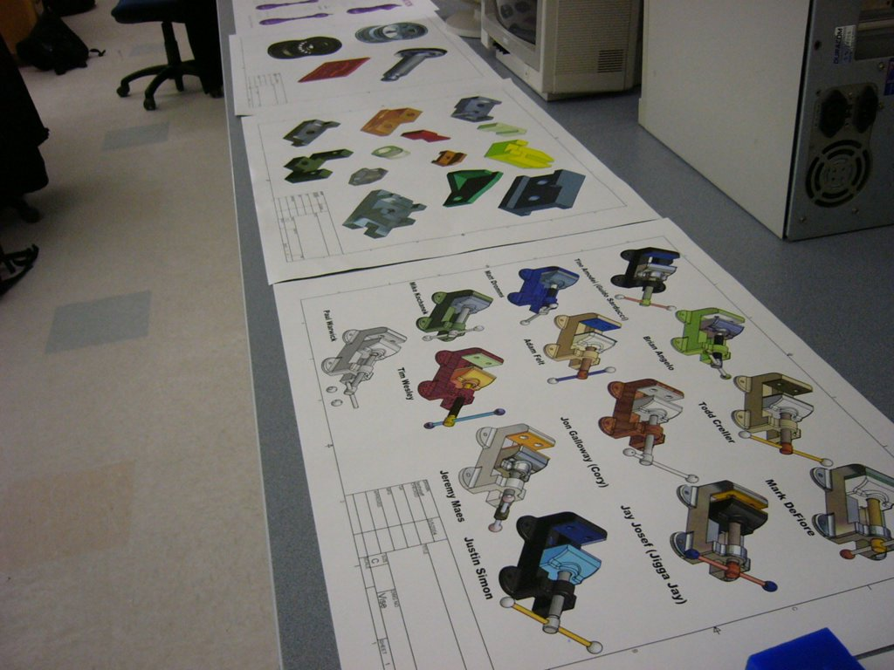
The Program (30 sh total)

Master of Science in Education - Major in Technology Education

 | - Professional Core (all required) | 18 sh
TED 531 | History and Philosophy of Technology Education | 3 sh
TED 532 | Advanced Instructional Methodologies for Technology Education | 3 sh
TED 533 | Curriculum Development for Technology Education | 3 sh
TED 534 | Assessment in Technology Education | 3 sh
TED 535 | Laboratory Instructional Environments in Technology Education | 3 sh
TED 536 | Introduction to Research for Technology Education | 3 sh
 | 2.0 Options (select one under advisement) | 12 sh
Option A | Research Project Option | 12 sh
TED 597 | Applied Research and Development Project | 3 sh
 | Directed Coursework (graduate level, under advisement) | 9 sh
 | or
Option B | Thesis Option | 12 sh
EDU 5xx | Methods and Techniques of Research (under advisement) | 3 sh
TED 598 | Thesis | 3 sh
 | Directed Coursework (graduate level, under advisement) | 6 sh
 | or
Option C | Directed Coursework Option  Courses may be selected from the College of Arts and Sciences, School of Education, or departmental electives (graduate level, under advisement) | 12 sh
 | 3.0 Assessments (all required)
1. | Candidacy Exam – written format. Apply in the Technology Department office between 12-18 sh or no later than semester 18 sh is attained
2. | Advancement to Candidacy for all three options requires; a cumulative average of 3.00 or better, successful completion of Candidacy Exam, and approval of a contract entitled Directed Coursework Proposal – graduate level courses (500 or above) achieving a cohesive professional competence – at or before taking Candidacy Exam
3. | Comprehensive Assessment – written, oral, and portfolio submission. Apply in the Technology Department office by the second week of LAST semester, offered during exam week
Advancement to Candidacy Assessment
Be sure to sign up for the next test date when you reach 12 sh completed. Not more than 18 hours should be attained before the exam is completed.

Contact the department office for the date of the test, given periodically.

1. Who must take the assessment?

A student admitted to graduate study must file for degree candidacy at the midpoint of the program. In the Department of Technology, maintaining a 3.0 grade point average and successfully completing the Advancement to Candidacy Assessment establish degree candidacy. All Technology Education students admitted to the program must take the assessment; students unconditionally admitted to the program cannot take the test.

2. Why do we have the assessment?

Many graduate programs include similar procedures. Programs having such procedures generally are perceived as more rigorous and of better quality than programs without some formal advancement procedure. In addition, the assessment allows the department to verify writing skills as well as the student's ability to take a position and logically defend that position using our written language. The assessment also can be used to sample a student's understanding of key concepts and themes within and across the graduate core courses. With the foregoing in mind, the assessment serves an important feedback purpose as well as providing an opportunity to better meet the needs of each student.
Call the office after 12 sh at 315.312.3011 - to get the assessment dates.

3. When is the assessment to be taken?

Students are to take the Advancement to Candidacy assessment after completion of between 12 and 18 semester hours of graduate course work. Not more than 18 semester hours should be taken without having completed the assessment. Hours beyond 18 will be subject to forfeiture.

4. What is the nature of the assessment?

The assessment consists of global questions taken from the core courses. The questions are designed to allow the student to synthesize material taken from the course and to cover relationships between this material and material taken from other courses within the program.

5. How is pass/fail determined?

A graduate faculty committee, using guidelines provided to them, grades the assessment. The assessment, or parts, may be repeated as many as three times, although the questions will not be the same as those previously failed.

6. When and how will I find out my assessment results?

Students will be notified in writing of the results. Notification shall come from the department chairperson and will specify total pass, total failure, or partial success. Where failure or partial failure is a problem, an attempt will be made to specify the inadequacies that may have led to failure.

7. What about deviations from the above?
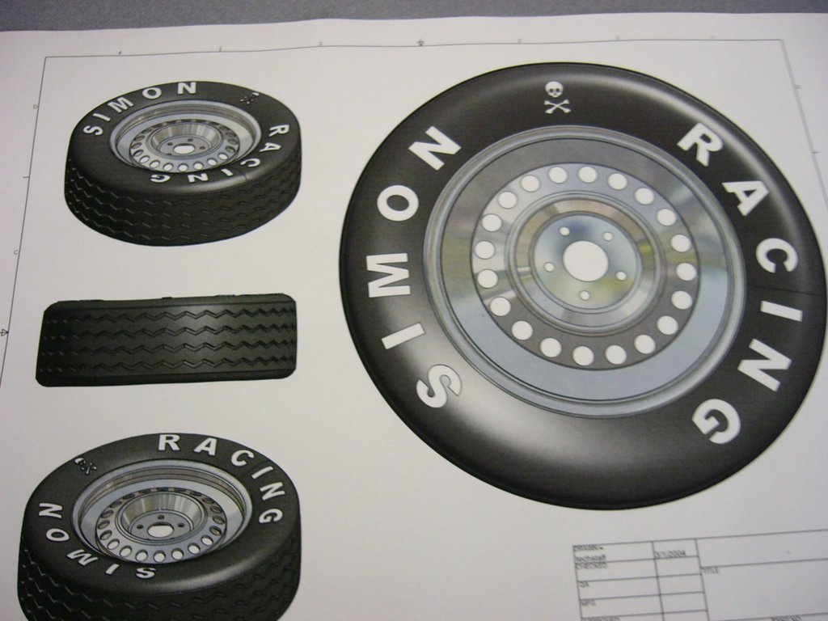

Handicapped students, international students, and others with sufficient justification may request an oral assessment rather than written. The chairman of the department may authorize deviations as well as consider other requests. It is not the intent of the department, however, to waive the assessment in any case.

8. How do I apply?

Applications for the Advancement to Candidacy Assessment are available from the office:

SUNY Oswego
Department of Technology
Park Hall,
Oswego, NY 13126
315-312-3011
livermon@oswego.edu (secretary)

Comprehensive Assessment

There will be a culminating experience that will take written form, oral form, or both. The student will present a long-term portfolio development to the examining faculty. The student must apply for this assessment in the department office no later than the close of the “add period” in their last semester (about the second week of school). It will be offered the last week of the last semester of graduate study.



Non-degree Graduate Study

Persons holding a bachelor's degree in Technology Education from an accredited college or university, with provisional certification to teach Technology Education or with eligibility for provisional certification, may be admitted with a non-degree status. These students may enroll in graduate courses providing all course prerequisites are met.

All non-degree graduate students are urged to meet with the department chairperson soon after admission to clarify their goals and make appropriate long range plans. The chairperson may assign an adviser if the study will be for an extended period of time.

Summer Session Overload
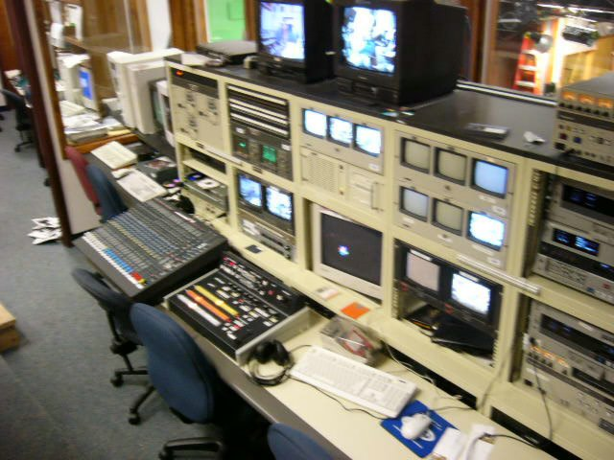
Generally, no more than1 sh in one week is the norm for SUNY classes. Technology Education graduate students may petition to enroll in 9 sh during a six week summer session if one of the following conditions exists:

1. The student will be taking graduate courses for the first time and had an undergraduate GPA of at least 2.75

- The student has a graduate index of at least 3.25. Students wishing to exercise this option must fill out an overload form, available in the department office.

Transfer Credit

Please see the "Graduate Catalog" for a complete description, under "Transfer Credit" in the index (rear of book). Generally, all credit for a M.S. degree must be earned within a seven-year period; only As and Bs are allowed; and six sh is the maximum.

Requirements for Completion of Degree

The following is a summary of the major requirements needed for completion of the M.S. degree:

1. Complete all coursework within seven years
2. Minimum of 24 sh taken at SUNY Oswego
3. Average GPA of 3.0 in Technology Education courses
4. Average GPA of 3.0 in all courses combined
- Passed Advancement to Candidacy Assessment
- Approved Directed Coursework Proposal
- Application for advanced degree filed (see graduate catalog for filing dates and procedures)
- Courses taken in appropriate core and Directed Coursework categories
- Completion of the Comprehensive Assessment

Graduate Assistantships

The Department of Technology anticipates having graduate assistantship positions available each year. It is the desire of the department that its graduate assistants proceed through the Master of Science degree program and also gain experiences with membership on a college faculty. Information about assistantships may be obtained from the department chairperson.

Graduate assistants are chosen from among the most qualified candidates in terms of:

1. Undergraduate record
2. Graduate admissions criteria
3. Compatibility with department needs
4. Evidence of demonstrated competence

The following college and department policies govern the graduate assistant program:

1. Expected to work 20 clock hours per week
2. Limited to an academic load of 9 sh
3. Must be accepted unconditionally into the M.S. program
4. Appointments are normally for one year
5. Faculty privileges available, such as office space, parking, library services, and bookstore
6. Expected to participate in department meetings
.

Combined Enrollment

(Admission of undergraduates to graduate courses for graduate credit)

Seniors who need nine hours or fewer to graduate may petition for combined enrollment if they meet the following terms and conditions:
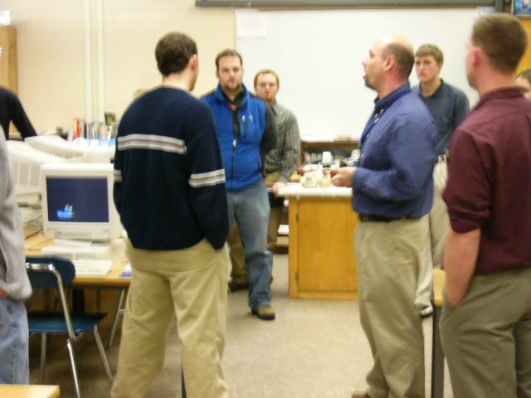

1. The petition form for combined enrollment may be secured at the Graduate Office.

2. The student has at least a 3.25 cumulative quality point index in the student's major and at least a 3.00 cumulative quality point index for all college work credited at SUNYCO. In exceptional circumstances a student who does not meet this requirement may petition through the chairperson of the department in which the course is offered to the appropriate dean for permission to enroll in graduate level courses.

3. The student has the approval of the student's adviser and the instructor of the course. The chair of the department in which the course is offered certifies to the appropriate dean that the student is qualified to take the course and that the student would substantially benefit by participation in the graduate course.

4. The student's class load cannot exceed 12 semester hours unless permission is requested by the student adviser and approved by the appropriate dean to increase the total to a maximum of 15 semester hours.

5. The completed petition and supporting documents must be submitted to the appropriate dean prior to the deadline for adding courses. The dean will maintain the appropriate records, will arrange the proper award of credit and will insure the integrity of the graduate level courses.

6. Granting of combined enrollment graduate credit is contingent upon completion of undergraduate degree requirements. Should, for any reason, a student taking combined enrollment courses not graduate at the end of the semester, all graduate credit will automatically revert to undergraduate credit.
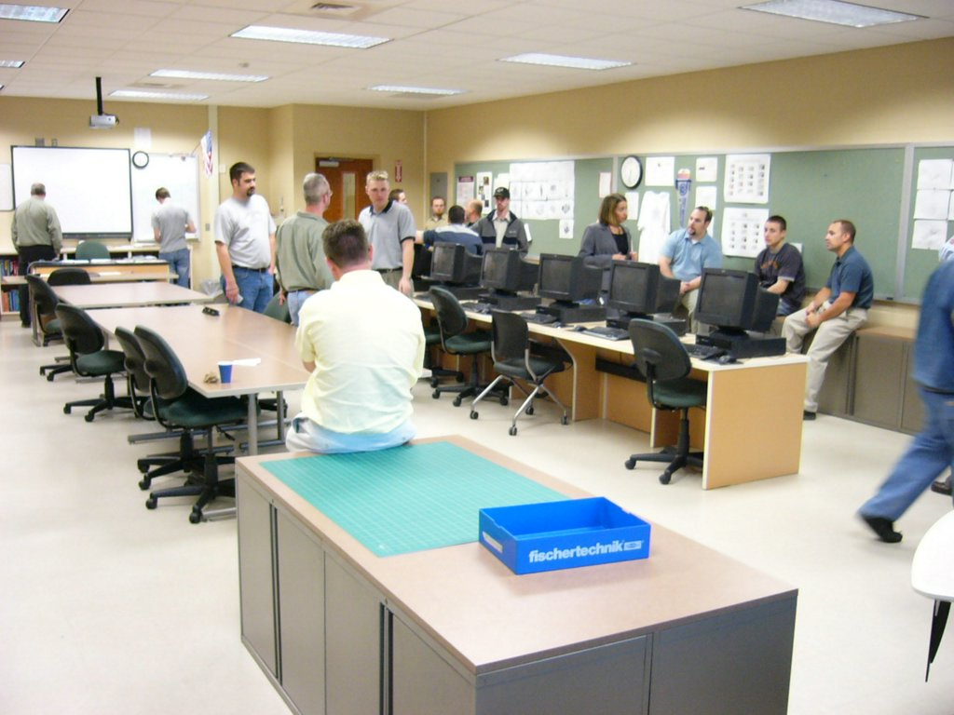

Academic Load

The normal maximum academic load for a graduate student is considered to be 12 sh of coursework. Graduate assistants are limited to 9 sh as an academic load.

Research Project Program (Option A)

This program option is designed for the student who would like to complete a research project that is not in a category that would be appropriate for a formal thesis. Such applied research projects as curriculum development, technical project R&D, design and innovation projects, teaching material development, and others are appropriate project areas for this option. This is an excellent option for those students who perceive a career goal in administrative ranks, yet do not believe they will continue on for the doctorate, as they can obtain practical, action-based research experience.

Thesis (Option B)

This program option is designed for the student who would like to complete a formal research activity, given specific parameters. Those who will possibly continue their graduate work toward the doctorate are highly encouraged to choose this option as it offers excellent preparation towards the development of a doctoral dissertation. Those who would like to have their credentials highly regarded in many sectors of the educational establishment should also consider this option.

Directed Coursework (Option C)

This program option is designed for those teachers who are obtaining their M.S. degree to receive professional certification and who expect to continue their entire career in the classroom. With adviser approval, 12 sh of graduate level courses should be selected to develop competence in specifically designated areas. Students must file an adviser signed Directed Coursework Proposal for the 12 sh to be applied to their program. This proposal must precede the coursework, and it may be changed due to circumstances, with adviser approval. Courses should not simply be selected at random from the available offerings.

Students considering remaining in the classroom for their career should also consider the research project or thesis option as they hold valuable experiences that cannot be obtained through additional coursework. In any event, the students should carefully select one of the three options with the help of the adviser.
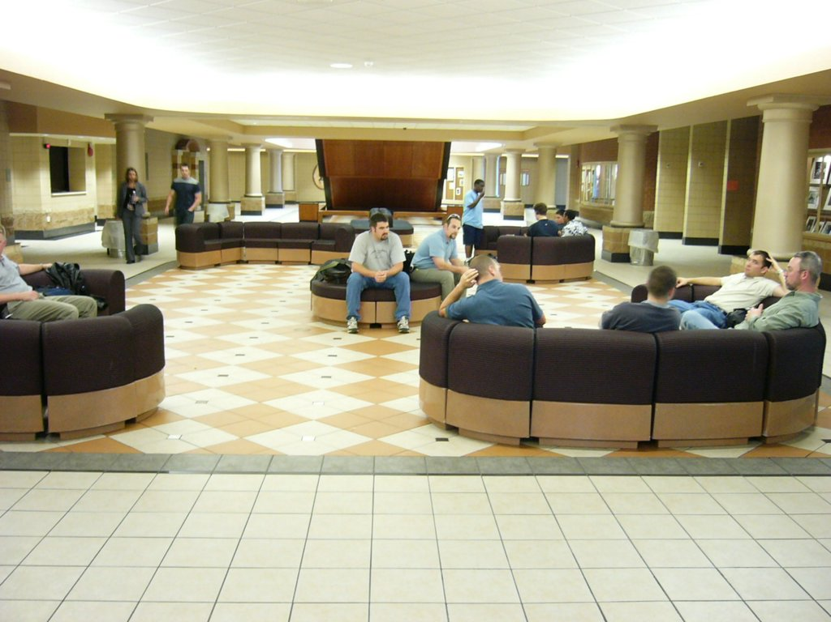

Traffic Safety Courses

Approval to teach driver education is a 12 sh sequence. After approval by the adviser in the Directed Coursework Proposal, the student of traffic safety coursework can use a maximum of 6 sh, if they are 500 level courses or above. The remaining 6 sh of traffics safety must be taken over and above graduation requirements

Long-range Offerings

The Department of Technology makes a concerted effort to offer graduate courses in a sequence that can provide maximum program efficiency for students. Courses are offered so students can complete the master's degree in three summers or in one calendar year. In order to finish in three summers some students will need to take one course during the academic year, either at SUNY Oswego or elsewhere. Prior approval for off-campus study is required for courses taken elsewhere.

It is possible for some students to finish in two summers at SUNY Oswego, provided six sh are earned during the academic year at SUNY Oswego or elsewhere. The adviser should be consulted for information on long-range planning. Any long-range plan should be approved by the graduate adviser, as must any changes made to the plan.

Graduate students who are full-time teachers and who desire to complete a master’s degree must make a commitment to spend two consecutive 9-week summers at SUNY Oswego to complete the six core courses. Most Technology Education courses are three weeks in length during the summer.


The Department of Technology proposed array of graduate course offerings, as follows, when demand dictates:

 | Fall | Spring | Summer
Even years (in Sept.)* | TED 534 - Assessment | TED 532 - Methodology | TED 532 - Methodology
 | TED 536 - Research |  | TED 534 - Assessment
 |  |  | TED 536 - Research
Odd years (in Sept.)** | TED 531 - History | TED 533 - Curriculum | TED 531 - History
 | TED 535 – Lab Environ |  | TED 533 - Curriculum
 |  |  | TED 535 - Lab Environ

* and alternate (even-numbered) academic years thereafter
** and alternate (odd-numbered) academic years thereafter

Graduate Independent Study
(TED 599 -- 1 to 4 semester hours)

1. Course Description

A course designed to provide time, facilities, and faculty guidance for individual students or groups of students who desire to pursue independent study, in depth, of a problem related to their field of professional and/or technological interest. Problems may utilize either campus or field resources.

2. Prerequisites

Open only to graduate students having completed nine or more semester hours of Department of Technology chairperson, adviser, and instructor required.

3. Justification

To provide qualified graduate students an opportunity for independent study within a specific area of their major not otherwise possible in courses offered by the department.

4. General Objectives

A. Develop attitudes and skills of independent study
B. Develop special interests of students
C. Provide an opportunity for exceptional students to pursue, in depth, a specific area of study related to their major curriculum area or related subject area

5. Course Outline

A. As an initial phase of advisement, the topic to be studied shall be established. The student is expected to present the problem, and shall work within the framework of:

- Introduction to research methods
- Identify and structure a problem
- Survey of resource materials
- Preparation of proposal
- Presentation of proposal
- Execution of proposal
- Report of results

B. The individual problem may be in the technical or professional areas of Technology Education. Technical or professional problems cannot be similar to existing courses. If so, the student must sign up for the course.

A technical problem requiring the use of facilities assumes that a technical staff member is willing to act as consultant and supervise the activity. Arrangements must be made with the technical instructor prior to enrollment in the course.
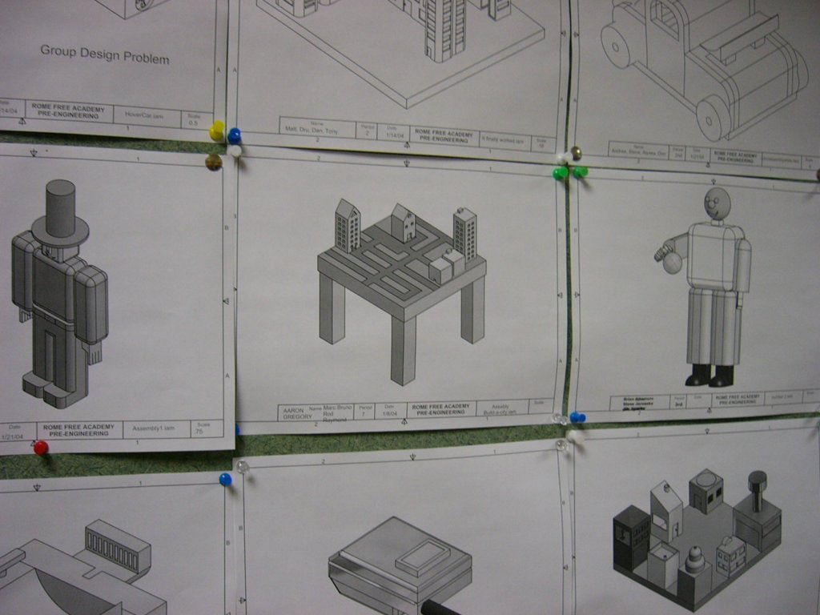

C. The student shall identify the problem and discuss it thoroughly with the instructor prior to the beginning of the semester or session of registration. If accepted, the student shall proceed to write up the full proposal in the form of a first chapter of a research report. The proposal must be approved before any further work is done.

- The student should be acquainted with related research and available resource material during the development of the proposal.
- The student should be acquainted with the development of a research report and the procedures involved.
- The research report shall follow the American Psychological Association standards.
- The independent study problem must be approved before any further action may be taken for credit.

D. Proposed time schedule of due dates (based on a 15-week semester):

1. Research paper approach:

a. Chapter I (Introduction to the Problem) completed and typed by end of the first three weeks

b. Chapter II (Review of Literature) completed and typed prior to mid-term week

c. Chapter III (Analysis of the Problem) and Chapter IV (Summary, Conclusions and Recommendations) completed and typed at least one week prior to end of scheduled classes

d. Completed report including Preface, Bibliography, and Appendix, assembled in binder, to be turned in for grading during final examination week

- Technical laboratory activity problem

a. Proposal for activity must be approved

b. Final report of technical activity shall generally follow above format with appropriate variations

3. If an independent study must extend over more than one semester or summer session, the registration for credit should occur during the semester or session in which the study will be completed

Department of Technology
www.oswego.edu/tech

APPROVAL FORM FOR ENROLLMENT IN TED 599 INDEPENDENT STUDY

PROCEDURE

The student is responsible for having Parts I and II completed prior to college registration. Part I must be returned to the department chairperson.

Student ______________________________ SS#___________________________________
Semester_____________________________ No. of credits ___________________________

PART I -- Departmental approval and prior arrangements:

- Student adviser approval: __________________________________ Date: __________

- Professor agreeing to supervise the TED 599 study:

__________________________________________________________ Date: __________

Brief statement of the problem and arrangements made to conduct this study:

__________________________________________________________________________

__________________________________________________________________________

__________________________________________________________________________

__________________________________________________________________________

__________________________________________________________________________

3. Chairperson or authorized approval _________________________Date: __________

Comments:

4. Expanded proposal: A copy of the TED 599 full proposal must be submitted to the department chairperson no later than the end of the first week of classes for attachment to Part I.

WW – 5/05

Department of Technology
www.oswego.edu/tech

LONG-RANGE PROGRAM PLANNING FORM
DEPARTMENT OF TECHNOLOGY
M.S. PROGRAM

Name: | SS#: | Phone:
Adviser: | e-mail: | Antic grad date:

Semester_____ Semester_____ Semester _____
______________ _____________ ____________
______________ _____________ ____________
______________ _____________ ____________
______________ _____________ ____________
______________ _____________ ____________

Total sh _____ Total sh _____ Total sh _____

Semester_____ Semester_____ Semester _____
______________ _____________ ____________
______________ _____________ ____________
______________ _____________ ____________
______________ _____________ ____________
______________ _____________ ____________

Total sh _____ Total sh _____ Total sh _____

Advancement to Candidacy Assessment: Semester ____(between 12 and 18 sh complete)

___________________________Date : _____ _____________________Date______
(Adviser signature) (Student signature)

Comprehensive Assessment Completed: Date Completed: _____________________

___________________________Date:______
(Adviser signature)

Notes:
1. This plan must be revised with adviser approval.
2. The student must consult with the adviser by phone, e-mail, or letter at these times:
a. prior to advanced registration
b. prior to registration for off-campus courses
c. after receiving a "C" or lower grade
d. after/during career or educational goal change
e. to explain unclear program requirements
3. Students must file a copy of the Long-Range Program Plan with the adviser. (WW – 5/05)

Department of Technology
www.oswego.edu/tech

RECORD OF PROGRESS
Master of Science in Education (30 sh)

Name: | SS#: | Phone:
Adviser: | e-mail: | Antic grad date:

SH GR SEM
1.0 Professional Core (18 sh)

- TED 531 History and Philosophy of Technology Education 3 ___ ___
- TED 532 Advanced Instructional Methodologies for TE 3 ___ ___
- TED 533 Curriculum Development for Technology Education 3 ___ ___
- TED 534 Assessment in Technology Education 3 ___ ___
- TED 535 Laboratory Instructional Environments in TE 3 ___ ___
- TED 536 Introduction to Research for Technology Education 3 ___ ___

2.0. Field-Related Options (12 sh - by advisement) - Select A, B, or C

Option A - Research Project Option (12 sh)

- TED 597-Applied Research and Development Project 3 ___ ___
- (Adviser approved) _________________________________ 3 ___ ___
- (Adviser approved) _________________________________ 3 ___ ___
- (Adviser approved) _________________________________ 3 ___ ___

Option B - Thesis Option (12 sh)

- EDU 596-Methods and Techniques of Research 3 ___ ___
- TED 598-Thesis 3 ___ ___
- (Adviser approved) _________________________________ 3 ___ ___
- (Adviser approved) _________________________________ 3 ___ ___

Option C - Directed Coursework Option (12 sh) - Courses must be selected under advisement, 500 Level or above, and not exceed 6 sh of transfer from another institution.

- (Adviser approved) _________________________________ 3 ___ ___
- (Adviser approved) _________________________________ 3 ___ ___
- (Adviser approved) _________________________________ 3 ___ ___
- (Adviser approved) _________________________________ 3 ___ ___

3.0 #1 Advancement to Candidacy Assessment Completed on ________________
#2 Comprehensive Assessment Completed on ________________
WW-5/05

Department of Technology
www.oswego.edu/tech

DIRECTED COURSEWORK PROPOSAL

DEPARTMENT OF TECHNOLOGY

Master of Science in Education

Option C - Directed Coursework Option (12 sh) - Courses must be selected under advisement, 500 level or above, and not exceed 6 sh of transfer from another institution.

Name: | SS#: | Phone:
Adviser: | e-mail: | Antic grad date:

Course Number | Course Title | sh | Projected semester | Adviser’s initials | Date

WW – 5/05

Department of Technology
www.oswego.edu/tech

Candidacy Application Form

Name: | SS#: | Phone:
Adviser: | e-mail: | Antic grad date:

Graduate core courses taken prior to Candidacy Assessment sh Sem/Yr

TED 531 History and Philosophy of Technology Education 3 ___ ___
TED 532 Advanced Instructional Methodologies for TE 3 ___ ___
TED 533 Curriculum Development for Technology Education 3 ___ ___
TED 534 Assessment in Technology Education 3 ___ ___
TED 535 Laboratory Instructional Environments in TE 3 ___ ___
TED 536 Introduction to Research for Technology Education 3 ___ ___

Select one:
A Option A – Research Project (12 sh)

Course Number Title Sem/Yr

TED 597 Research Project ______
_____________ __________________________________________ ______

_____________ __________________________________________ ______

_____________ __________________________________________ ______

__________________________________ ______________________________________
(Project adviser signature) (Program adviser signature)

B Option B – Thesis (12 sh)
Course Number Title Sem/Yr

EDU 596 Research Methods ______
TED 598 Thesis ______

_____________ __________________-________________________ ______

_____________ ___________________________________________ ______
__________________________________ ______________________________________
(Project Adviser signature) (Program adviser signature)

C Option C – Directed Coursework Proposed (12 sh)
Course Number Title Sem/Yr

_____________ _______________________________________ ______

_____________ _______________________________________ ______

_____________ _______________________________________ ______

_____________ _______________________________________ ______

__________________________________ Revision dates and initial:
(Program adviser signature)

Graduate Review Committee (signatures/date)

_____________________________________________ __________
(signature) (date)

_____________________________________________ __________
(signature) (date)

_____________________________________________ __________
(signature) (date)

Whitfield 05

